VIDYA BHUSHAN
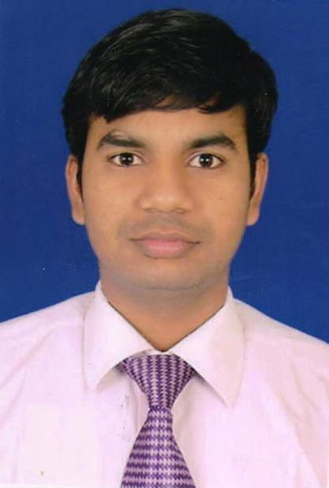
Mobile: +91-9540760785~ E-Mail: vidyabhushan1993@gmail.com
Address: Sarai Khawaza, House No.269, Faridabad- 121003
Seeking assignments in Electrical Engineering with an organization of high repute.

SYNOPSIS

- A dedicated, result oriented candidate with more than 2 year of work experience in B.Tech. Electrical Engineering.
- Currently working as Electrical Engineer – Asst. Manager Business Development with Indra Electrical Controls for L&T LV switchgear& Rittal Panel Ac.
- Completed summer internships at Gemco Controls Limited, Faridabad and Medors Biotech Pvt. Ltd., Delhi.
- Familiar with modules of Power System Analysis, Electrical Instrument, Testing & Maintenance and Power Electronics.
- Successfully completed academic projects on Automatic Eco-friendly Car, Automatic Wheel Chair, Sensing System and Power Generation System.
- Conversant with Windows, MS Office and Internet Applications.
- An effective communicator with excellent interpersonal, logical thinking & analytical abilities.

AREA OF INTEREST

- Sales & Business Development
- Power Generation, Transmission & Distribution System
- Production and its Maintenance
- Research and Development

SUMMER INTERNSHIPS

Organization : Gemco Controls Limited, Faridabad
Project Title : Electric Drive and Control
Duration : 6 weeks

Organization : Medors Biotech Pvt. Ltd., Faridabad
Project Title : Solar Systems
Duration : 6 weeks

Organization : Larsen & Toubro
Project Title : Electrical & Automation
Duration : 6 Month

ACADEMIC PROJECTS HANDLED

- Worked on the following projects:
- Automatic Eco-friendly Car (Award winning)
- Automatic Wheel Chair
- Sensing System (Employed in street light)
- Power Generation System (Employed in Speed Breaker)

SHOLASTIC

2015 B.Tech.in Electrical Engineering from Maharshi Dayanand University with 68%
2011 12thfrom Board of School Education, Haryana with 77% marks
2009 10thfrom Board of School Education, Haryana with 77% marks

POST QUALIFICATION EXPERIENCES

I did work as an Electrical Sales Engineer at Low Voltage Switchgear for L&T at third party pay role (May’2015-April’2016).
I was handling products like MCB, MCCB, ACB, contactors & Few of Control Accessories.
Also worked with Application control Panel (April 2016 to Oct)
I worked with Enfrosun Power. It’s Solar system integrator. Dec 2016 to May 2017.

Roles and Responsibilities with Current Company:
1. Handling the business and making new clients for the company in Delhi, Haryana.
2. Explaining the technical specifications to the customers.
3. Participating in meetings with Government agency, Client & vendor weekly.
4. Developing new relations and business for the company and outreaching new customers.
5. Providing the relevant support to the customers and clients.
6. Analyzing the market competition, customer needs pricing and making strategies for further prospects.
7. Work at end user client.
8. Benefit Analysis, Payback calculation.
9. Technical working for panel Ac.
10. HVAC consultant for panel business.

Our few customers:
1. Industrial Sector Client Wunder Control, Application control Talbros, Digi Drive etc.
2. Govt. Client: IOCL, NDMC, DMRC etc.
3. End-user Amul, Kwality, etc.

EXTRA MULAR ENGAGEMENTS

- Participated in various cultural activities held at School and College level.
- Coordinated and organized events at College level.

IT SKILLS

- Well versed with MS Office and Internet Applications.

PERSONAL DOSSIER

Date of Birth : 21st February 1995
Languages Known : English, Hindi and basics of Sanskrit

